**TOTAL REVENUE**

SELECT sum(total_price) as total_revenue FROM `intrepid-pride-422806-k2.pizzsales2023.Sales2023`

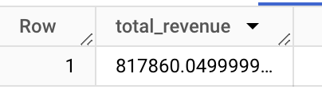

**TOTAL PIZZA SOLD**

**SELECT sum(quantity) as tot_pizza_sold FROM `intrepid-pride-422806-k2.pizzsales2023.Sales2023`**

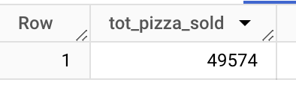

**TOTAL ORDERS**

**SELECT count(distinct order_id) as total_order FROM `intrepid-pride-422806-k2.pizzsales2023.Sales2023`**

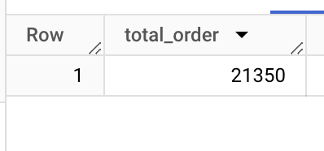

**SALE % BY PIZZA SIZE**

**SELECT**

**pizza_size,**

**CAST(SUM(total_price) AS NUMERIC) AS Total_Revenue,**

**CAST(SUM(total_price) * 100 /**

**(SELECT SUM(total_price) FROM `intrepid-pride-422806-k2.pizzsales2023.Sales2023` ) AS NUMERIC) AS PCT**

**FROM `intrepid-pride-422806-k2.pizzsales2023.Sales2023`**

**GROUP BY**

**pizza_size**

**ORDER BY**

**Pizza_size;**

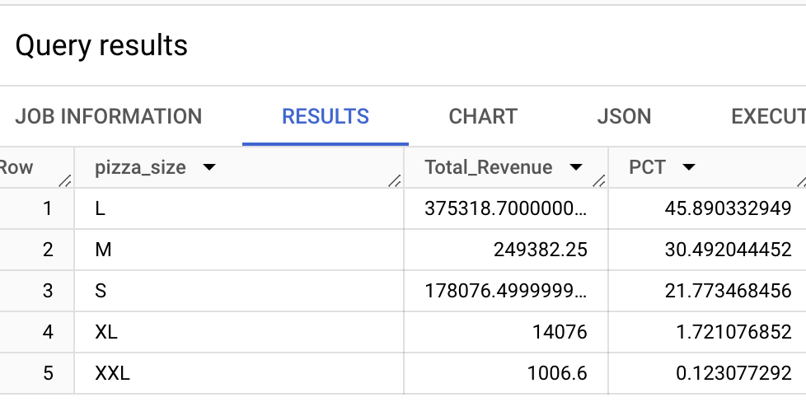

**% OF SALES BY PIZZA TYPE**

**SELECT**

**pizza_category,**

**CAST(SUM(total_price) AS NUMERIC) AS Total_Revenue,**

**CAST(SUM(total_price) * 100 /**

**(SELECT SUM(total_price) FROM `intrepid-pride-422806-k2.pizzsales2023.Sales2023` ) AS NUMERIC) AS PCT**

**FROM `intrepid-pride-422806-k2.pizzsales2023.Sales2023`**

**GROUP BY pizza_category;**

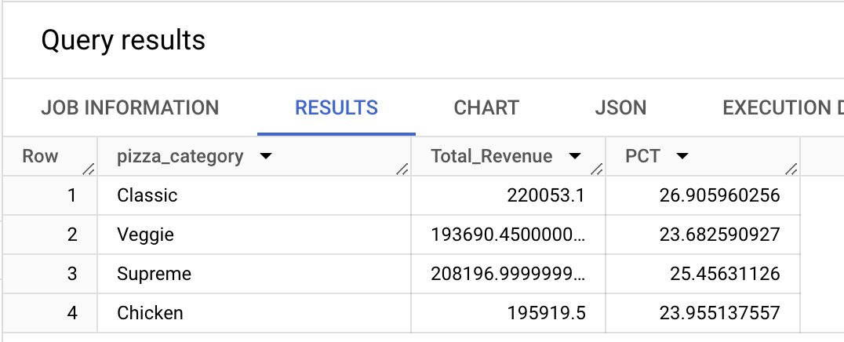

# **pizza sold per each category**

**SELECT**

**pizza_category,**

**SUM(quantity) AS Total_Quantity_Sold**

**FROM `intrepid-pride-422806-k2.pizzsales2023.Sales2023`**

**WHERE**

**EXTRACT(MONTH FROM order_date) = 2**

**GROUP BY**

**pizza_category**

**ORDER BY**

**Total_Quantity_Sold DESC;**

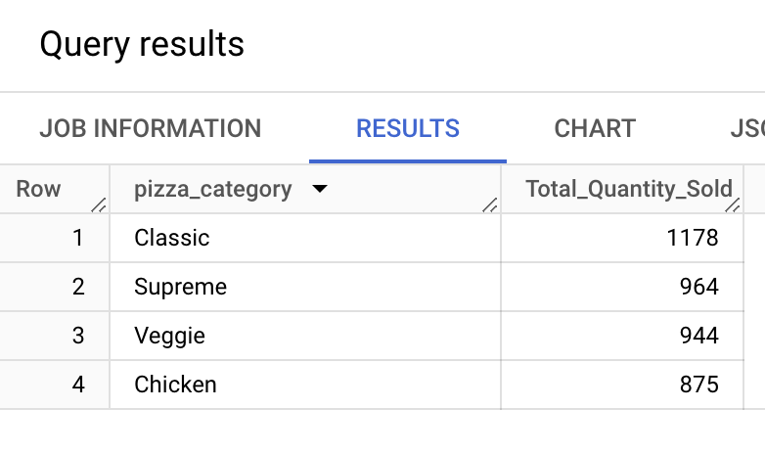

# **monthly trends for orders**

**SELECT**

**FORMAT_DATE('%B', order_date) AS Month_Name,**

**COUNT(DISTINCT order_id) AS Total_Orders**

**FROM `intrepid-pride-422806-k2.pizzsales2023.Sales2023`**

**GROUP BY Month_Name**

**ORDER BY Total_Orders;**

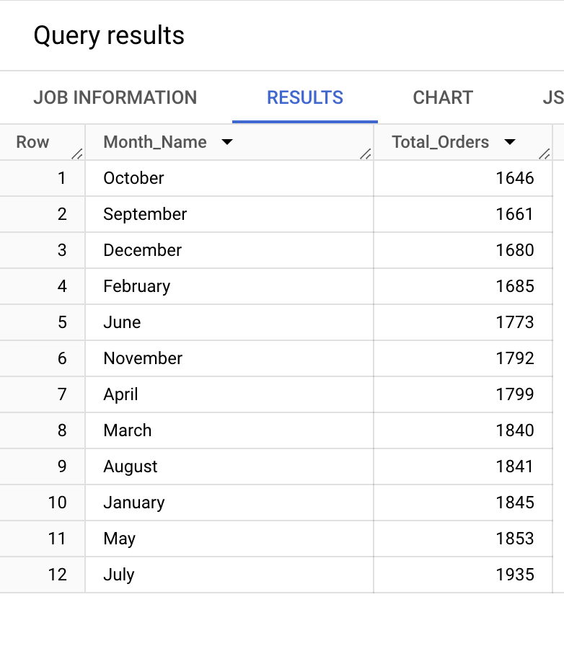

# **daily trends for orders**

SELECT

FORMAT_DATE('%A', order_date) AS Order_Day,

COUNT(DISTINCT order_id) AS Total_Orders

FROM `intrepid-pride-422806-k2.pizzsales2023.Sales2023`

GROUP BY Order_Day

ORDER BY Total_Orders;

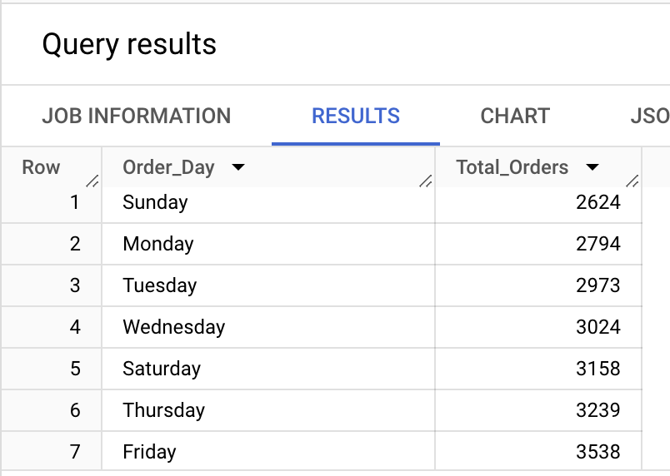

**BOTTOM 5 PIZZAS BY TOTAL ORDERS**

**SELECT pizza_name, SUM(quantity) AS Total_Pizza_Sold**

**FROM `intrepid-pride-422806-k2.pizzsales2023.Sales2023`**

**GROUP BY pizza_name**

**ORDER BY Total_Pizza_Sold**

**LIMIT 5;**

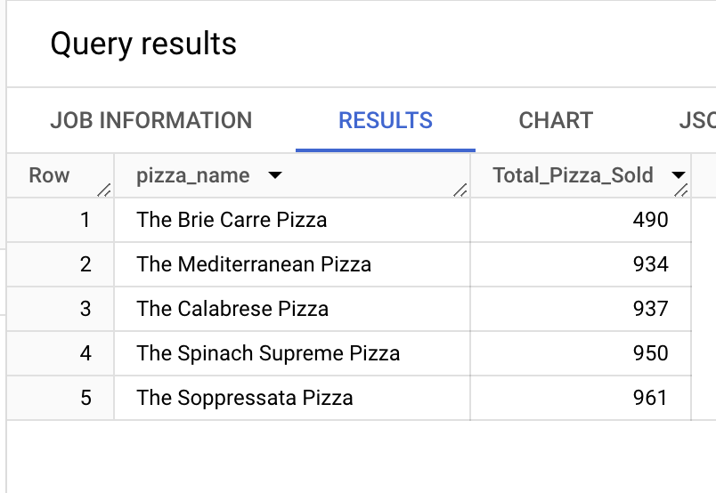

# **avg pizza per order**

**SELECT sum(quantity)/count(distinct order_id) as avg_pizza_per_order FROM `intrepid-pride-422806-k2.pizzsales2023.Sales2023`**

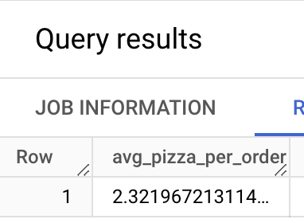

# **avg order value**

**SELECT (sum(total_price)/count(distinct order_id)) as avg_order_value FROM `intrepid-pride-422806-k2.pizzsales2023.Sales2023`**

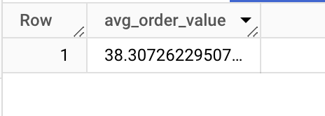

# **Top 5 Pizzas by Total Orders:**

**SELECT**

**pizza_name,**

**COUNT(DISTINCT order_id) AS Total_Orders**

**FROM `intrepid-pride-422806-k2.pizzsales2023.Sales2023`**

**GROUP BY**

**pizza_name**

**ORDER BY**

**Total_Orders DESC**

**LIMIT 5;**

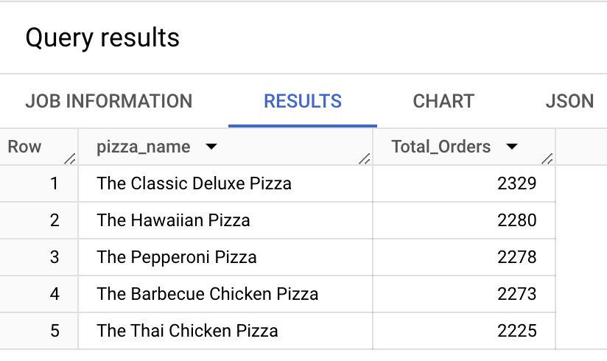

# **Top 5 Pizzas by Revenue:**

# **SELECT**

# **pizza_name,**

# **SUM(total_price) AS Total_Revenue**

# **FROM `intrepid-pride-422806-k2.pizzsales2023.Sales2023`**

# **GROUP BY**

# **pizza_name**

# **ORDER BY**

# **Total_Revenue DESC**

# **LIMIT 5;**

# 

# 

# 

# **Bottom 5 Pizzas by Revenue:**

SELECT

pizza_name,

SUM(total_price) AS Total_Revenue

FROM `intrepid-pride-422806-k2.pizzsales2023.Sales2023`

GROUP BY

pizza_name

ORDER BY

Total_Revenue ASC

LIMIT 5;

